• Default Behavior: By default, Playwright runs test files in parallel but executes the tests within those files sequentially.
• What fullyParallel: true does: It allows individual tests within the same file to run in separate worker processes simultaneously.
• Worker Limits: If you want to limit how many tests run at once, use the workers property (e.g., workers: 4).

import { defineConfig } from '@playwright/test'; export default defineConfig({ // Run tests in files in parallel fullyParallel: true, // You can also define the number of workers to use workers: process.env.CI ? 1 : undefined, });

Observations:

- npx playwright test – runs test files in parallel mode , while the tests in each file runs sequentially – Workers – not defined in playwright.config.js file – Default way of running.
Shows 10 test cases with 4 workers – It might me different in different machine. Lots of test cases failed

- npx playwright test – runs test files in parallel mode , while the tests in each file runs sequentially – Workers – 2 defined in playwright.config.js file – Default way of running.
Shows 10 test cases with 2 workers - a smaller number of test cases failed

- npx playwright test tests/UiTestPOMParameterizationFixture.spec.js --config playwright.config1.js --project=Chrome – run with playwright.config1.js file - Workers none defined in playwright.config1.js file – project Chrome – Passed test cases – Ran the test cases in test file sequentially using 1 Worker

- npx playwright test tests/UiTestPOMParameterizationFixture.spec.js --config playwright.config1.js --project=Chrome – run with playwright.config1.js file - Workers 3 defined in playwright.config1.js file – project Chrome – Passed test cases – Ran the test cases in test file sequentially using 1 Worker
- npx playwright test tests/UiTestPOMParameterizationFixture.spec.js --config playwright.config1.js --project=Chrome – run with playwright.config1.js file - Workers 2 defined in playwright.config1.js file – project Chrome – Passed test cases – Ran the test cases in test file sequentially using 1 Worker
- npx playwright test tests/UiTestPOMParameterizationFixture.spec.js --config playwright.config1.js --project=Chrome – run with playwright.config1.js file - Workers none defined in playwright.config1.js file – project Chrome – fullyParallel is true - Passed test cases – Ran the test cases in test file sequentially using 2 Worker
- npx playwright test tests/UiTestPOMParameterizationFixture.spec.js --config playwright.config1.js --project=Chrome – run with playwright.config1.js file - Workers 1 defined in playwright.config1.js file – project Chrome – fullyParallel is true - Passed test cases – Ran the test cases in test file sequentially using 1 Worker - Running 2 tests using 1 worker
- npx playwright test tests/UiTestPOMParameterizationFixture.spec.js --config playwright.config1.js --project=Chrome – run with playwright.config1.js file - Workers 2 defined in playwright.config1.js file – project Chrome – fullyParallel is true - Passed test cases – Ran the test cases in test file sequentially using 1 Worker - Running 2 tests using 2 workers

- Inference with fullyParallel being true and worker set to none, test cases in test spec file run parallel.
- Inference with fullyParallel being true and worker set to 1 or 2 , test cases in test spec file run with 1 or 2 workers as set. fullyParallel gets overridden.

- test.describe.configure({mode:”parallel”) – In Test spec file will run the test cases in test file in parallel. Here test cases are not dependent. Workaround for fullyParallel used in playwright config file

- test.describe.configure({mode:”serial”) – In Test spec file will run the test cases in test file in serial. Used when test cases in test file are dependent . If “test B” depends on “test A” and “test A” fails , “test b” will skip.
- // Retry on CI only.
retries: process.env.CI ? 2 : 0,
process.env.CI: This checks if the code is running in a Continuous Integration environment (like GitHub Actions, GitLab CI, or Jenkins). These environments almost always set an environment variable named CI to true.
? 2 : 0: This is a ternary operator (an if/else shorthand).
- If CI is true, use 2 retries.
- If CI is false (e.g., you are running it locally on your own computer), use 0 retries

- // Opt out of parallel tests on CI.
workers: process.env.CI ? 1 : undefined,
workers: This determines the number of CPU cores or "threads" used to run tests in parallel.
process.env.CI ? 1 : undefined: This is a conditional (ternary) operator:
If on CI (process.env.CI is true): It sets workers to 1. This forces tests to run one after another (serially) to prevent resource crashes or "flaky" results on limited Continuous Integration servers (like GitHub Actions or Jenkins).
If NOT on CI (undefined): It uses the default setting (usually the number of cores on your local machine), allowing tests to run as fast as possible in parallel.
In short: It slows down the tests to 1-at-a-time when running on a server to ensure reliability, but keeps them fast on your local computer.
- // Fail the build on CI if you accidentally left test.only in the source code.
forbidOnly: !!process.env.CI,

How Playwright parallel execution works
Playwright runs tests using worker processes. Each worker is an independent OS process with its own browser instance, memory, and test data.
When you run npx playwright test, the test runner spins up multiple workers and assigns test files to them. Each worker picks up a file, runs all the tests inside it, then grabs the next available file.
Here's what that means in practice:
- Test files run in parallel across workers
- Tests inside a single file run sequentially, one after another
- Workers never share state
That's the default behavior. No config changes needed.
But there are actually 3 layers of parallelism in Playwright. Most teams only know about the first.
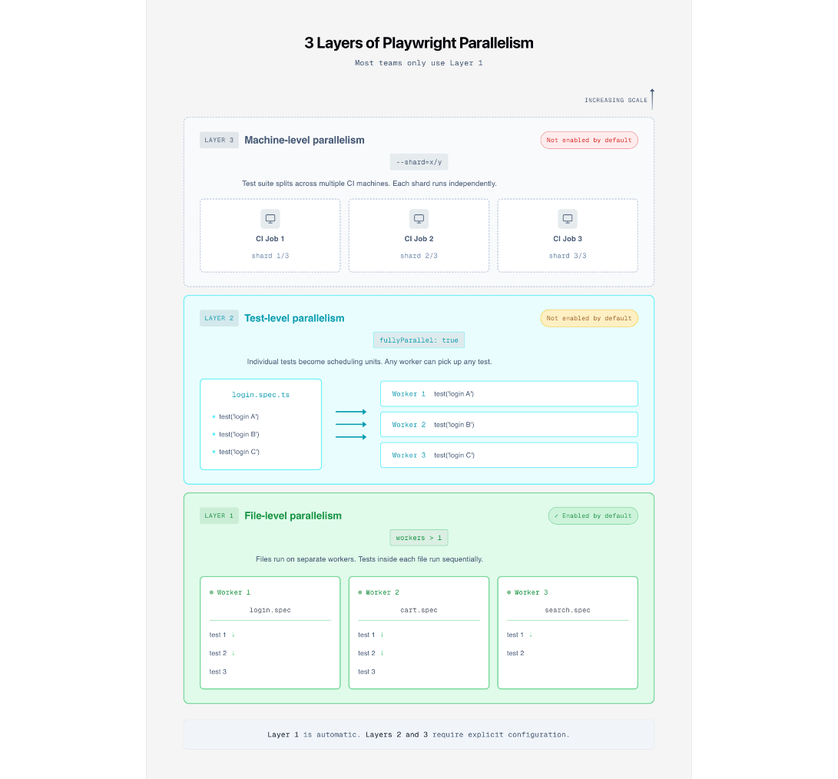
Layer | What it controls | Enabled by default? | How to enable
File-level | Different test files run on different workers | Yes | Automatic with workers > 1
Test-level | Individual tests within a file run on separate workers | No | fullyParallel: true or test.describe.configure({ mode: 'parallel' })
Machine-level | The test suite is split across multiple CI machines | No | --shard=x/y CLI flag
Layer 1 is already active. Layer 2 is what fullyParallel controls. Layer 3 is Playwright sharding, which we've covered separately.
The rest of this guide focuses on layers 1 and 2, which run on a single machine.

Configuring workers in playwright.config.ts
The workers option in your Playwright config controls how many parallel processes run your tests. You can set it as a number, a percentage string, or leave it undefined.
Worker count options
playwright.config.ts
// playwright.config.ts
import { defineConfig } from '@playwright/test';
export default defineConfig({
// Use 2 workers in CI, default locally
workers: process.env.CI ? 2 : undefined,
});

You can also override from the command line:
terminal
npx playwright test --workers 4
The CLI flag always wins over the config file.
Value | Behavior | Best for
undefined | Half of the CPU cores | Local development (Playwright default)
1 | Sequential, no parallelism | Debugging, fragile environments
4 | Exactly 4 workers | CI runners with known CPU count
'50%' | Half of the available cores | Flexible across different machines
'100%' | All CPU cores | Machines dedicated to testing only
Note: The Playwright CI docs recommend workers: 1 in CI for stability. That's a safe starting point. If your tests are well isolated, you can increase them from there.

How many workers should you use?
Every competitor article says "experiment." That's true, but not helpful when you're starting from zero.
Here's a practical starting point based on suite size and CI resources:
Suite size | CI environment | Recommended workers | Rationale
Under 50 tests | Any | undefined (default) | Not enough tests to benefit from tuning
50 to 200 tests | 2 vCPU runner | 2 | Matches available cores
50 to 200 tests | 4 vCPU runner | 3 to 4 | Leave some headroom for browser processes
200+ tests | 4+ vCPU runner | 4 to 6, then consider sharding | Single machine starts hitting diminishing returns
Flaky tests appearing after increasing workers | Any | Reduce by 1 to 2 and recheck | Resource contention is likely the cause
The key principle: each worker runs its own browser. A 2 vCPU machine running 4 workers is launching 4 Chrome instances on 2 cores. That's a recipe for timeouts.
Start conservative. Increase by 1. Watch for flakiness. That's the real "experiment

What fullyParallel actually does (and what it doesn't)
This is the most misunderstood config option in Playwright's parallelism model.
fullyParallel controls whether tests inside a single file get distributed to separate workers. That's it.
fullyParallel at the config level
With fullyParallel: false (the default), Playwright assigns an entire file to one worker. All tests in that file run sequentially, in order, within that worker.
With fullyParallel: true, each test becomes its own task in the scheduler queue. A file with 10 tests now creates 10 separate tasks that any available worker can pick up.
playwright.config.ts
// playwright.config.ts
import { defineConfig } from '@playwright/test';
export default defineConfig({
fullyParallel: true, // individual tests become the scheduling unit
});
You can also enable it for a single project instead of globally:
playwright.config.ts
// playwright.config.ts
import { defineConfig, devices } from '@playwright/test';
export default defineConfig({
projects: [
{
name: 'chromium',
use: { ...devices['Desktop Chrome'] },
fullyParallel: true, // only this project runs tests in parallel
},
],
});
The fullyParallel misconception
Here's where most teams get confused.
Enabling fullyParallel: true does not mean your Chrome and Firefox projects will run simultaneously. Playwright's scheduler assigns the next available task to the next available worker, regardless of the project it belongs to. If all Chrome tests finish first, every worker switches to Firefox.
The "parallelism" here is about task granularity, not project distribution.
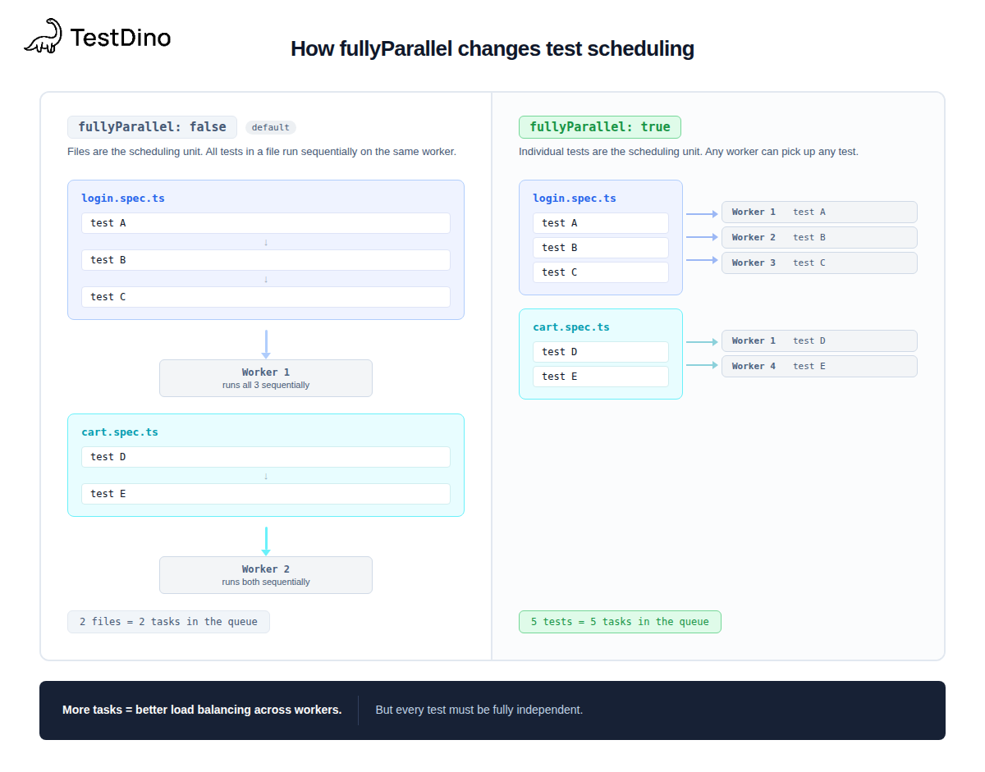
Aspect | fullyParallel: false | fullyParallel: true
Scheduling unit | Entire file | Individual test
Tests in same file | Run sequentially in one worker | Distributed across any available worker
beforeAll / afterAll | Run once per file | Run separately for each test (each gets its own hooks)
Best for | Files with tests that depend on order | Files with fully independent tests
Risk | Slower if files have many tests | Shared state bugs surface immediately
Effect on sharding | Shards split by file count | Shards split by test count (more balanced)

Tip: The Playwright sharding docs recommend fullyParallel: true when using shards. It creates more granular tasks, resulting in a more even distribution of work across shards.
If you're seeing flaky test failures after enabling fullyParallel, the likely cause is shared state between tests in the same file. Fix the isolation first, then re-enable.

Execution modes: parallel, serial, and default
Beyond the global config, Playwright gives you per-file control with test.describe.configure().
3 modes, each with different behavior.
parallel mode
Forces tests inside a file to run on separate workers, even if fullyParallel is off globally. Use this for files full of independent tests.
tests/product-search.spec.ts
// tests/product-search.spec.ts
import { test, expect } from '@playwright/test';
test.describe.configure({ mode: 'parallel' });
test('search by product name', async ({ page }) => {
await page.goto('https://storedemo.cms.testdino.com/products');
await page.getByTestId('header-menu-all-products').click();
// independent search test
});
test('filter by category', async ({ page }) => {
await page.goto('https://storedemo.cms.testdino.com/products');
// independent filter test, runs on a separate worker
});
Important: In parallel mode, beforeAll and afterAll run separately for each test, not once for the whole file. If your beforeAll sets up shared state (such as a database connection), parallel mode will create a separate connection for each test.
serial mode
Tests run in sequence. If one fails, all remaining tests in the group are skipped. Playwright explicitly discourages this mode. Use it only when tests genuinely depend on each other.
tests/checkout-flow.spec.ts
// tests/checkout-flow.spec.ts
import { test, expect } from '@playwright/test';
test.describe.configure({ mode: 'serial' });
test('register new account', async ({ page }) => {
await page.goto('https://storedemo.cms.testdino.com/');
await page.getByTestId('header-user-icon').click();
await page.getByTestId('login-signup-link').click();
await page.getByTestId('signup-email-input').fill(`user.${Date.now()}@test.com`);
// ... complete registration
});
test('login with new account', async ({ page }) => {
// depends on registration above, skips if registration fails
});
Note: Serial mode often indicates that tests should be combined into a single test. If step 2 can't run without step 1, they're not really separate tests. Splitting them only adds overhead.
default mode (opting out of fullyParallel)
When fullyParallel: true is set globally, specific describe blocks can opt out by setting mode: 'default'. Tests inside revert to sequential execution within their file.
checkout.spec.ts
test.describe('checkout flow', () => {
test.describe.configure({ mode: 'default' });
test('add to cart', async ({ page }) => {
await page.goto('https://storedemo.cms.testdino.com/');
await page.getByTestId('header-menu-all-products').click();
// runs first
});
test('complete checkout', async ({ page }) => {
// runs second, in the same worker
});
});
Here's when to use each:
Mode | On failure | Hooks behavior | Use when
parallel | Other tests keep running | beforeAll/afterAll per test | Tests are fully independent
serial | Remaining tests skip | Shared across the group | Multi-step flows with hard dependencies
default | Other tests keep running | Shared across the file | Opting out of fullyParallel for specific files
Need help debugging failures when switching modes? Start with the default, verify that the tests pass, then move to parallel, one file at a time.
Refer - https://testdino.com/blog/playwright-parallel-execution
Sharding
Introduction
By default, Playwright runs test files in parallel and strives for optimal utilization of CPU cores on your machine. In order to achieve even greater parallelisation, you can further scale Playwright test execution by running tests on multiple machines simultaneously. We call this mode of operation "sharding". Sharding in Playwright means splitting your tests into smaller parts called "shards". Each shard is like a separate job that can run independently. The whole purpose is to divide your tests to speed up test runtime.
When you shard your tests, each shard can run on its own, utilizing the available CPU cores. This helps speed up the testing process by doing tasks simultaneously.
In a CI pipeline, each shard can run as a separate job, making use of the hardware resources available in your CI pipeline, like CPU cores, to run tests faster.
Sharding tests between multiple machines
To shard the test suite, pass --shard=x/y to the command line. For example, to split the suite into four shards, each running one fourth of the tests:
npx playwright test --shard=1/4
npx playwright test --shard=2/4
npx playwright test --shard=3/4
npx playwright test --shard=4/4
Now, if you run these shards in parallel on different jobs, your test suite completes four times faster.
Note that Playwright can only shard tests that can be run in parallel. By default, this means Playwright will shard test files. Learn about other options in the parallelism guide.
Balancing Shards
Sharding can be done at two levels of granularity depending on whether you use the testProject.fullyParallel option or not. This affects how the tests are balanced across the shards.
Sharding with fullyParallel
When fullyParallel: true is enabled, Playwright Test runs individual tests in parallel across multiple shards, ensuring each shard receives an even distribution of tests. This allows for test-level granularity, meaning each shard will attempt to balance the number of individual tests it runs. This is the preferred mode for ensuring even load distribution when sharding, as Playwright can optimize shard execution based on the total number of tests.
Sharding without fullyParallel
Without the fullyParallel setting, Playwright Test defaults to file-level granularity, meaning entire test files are assigned to shards (note that the same file may be assigned to different shards across different projects). In this case, the number of tests per file can greatly influence shard distribution. If your test files are not evenly sized (i.e., some files contain many more tests than others), certain shards may end up running significantly more tests, while others may run fewer or even none.
Key Takeaways:
- With fullyParallel: true: Tests are split at the individual test level, leading to more balanced shard execution.
- Without fullyParallel: Tests are split at the file level, so to balance the shards, it's important to keep your test files small and evenly sized.
- To ensure the most effective use of sharding, especially in CI environments, it is recommended to use fullyParallel: true when aiming for balanced distribution across shards. Otherwise, you may need to manually organize your test files to avoid imbalances.
Merging reports from multiple shards
In the previous example, each test shard has its own test report. If you want to have a combined report showing all the test results from all the shards, you can merge them.
Start with adding blob reporter to the config when running on CI:
playwright.config.ts
export default defineConfig({
testDir: './tests',
reporter: process.env.CI ? 'blob' : 'html',
});
Blob report contains information about all the tests that were run and their results as well as all test attachments such as traces and screenshot diffs. Blob reports can be merged and converted to any other Playwright report. By default, blob report will be generated into blob-report directory. You can learn about blob report options here.
To merge reports from multiple shards, put the blob report files into a single directory, for example all-blob-reports. Blob report names contain shard number, so they will not clash.
Afterwards, run npx playwright merge-reports command:
npx playwright merge-reports --reporter html ./all-blob-reports
This will produce a standard HTML report into playwright-report directory.

